Daniel Ingram, Hayden Michael, Katlyn Murphy

CSC 440  12/2/2021

TEAM GRADE TRACKING SYSTEM PROJECT

Table of Contents

I. Introduction 3

A. Problem Statement 3

B. Proposal 3

II. System Description 3

III. System Requirements 3

A. Functional Requirements 3

IV. Use Case Diagram 27

V. Class Diagram 28

VI. Sequence Diagrams 29

VII. State Diagram 33

33

VIII. Activity Diagrams 34

IX. Database Design 39

A. ER Schema 39

B. Table Schema 39

X. Conclusion 40

XI. Data Dictionary 40

Table of Figures

Figure 1. Use Case Diagram 27

Figure 2. Class Diagram 28

Figure 3. Sequence Diagram - Manually Add Grades 29

Figure 4. Sequence Diagram - Edit Grades 30

Figure 5. Sequence Diagram - Delete Grades 31

Figure 6. Sequence Diagram - Generate Transcripts 32

Figure 7. State Diagram 33

Figure 9. Activity Diagram - Automatically Add Grades 34

Figure 10. Activity Diagram - Manually Add Grades 35

Figure 11. Activity Diagram - Edit Grades 36

Figure 12. Activity Diagram - Delete Grades 37

Figure 13. Activity Diagram - Generate Transcripts 38

Figure 14. ER Schema 39

# Introduction

## Problem Statement

EKU’s Registrar Office needs to update student course records after receiving student grades from all of the faculty at the end of each semester. Each faculty member provides the office an Excel file with letter grades (A, B, C, D, or F) of the students who took course(s) with them. The office is asking us to develop a system to manage the data for them.

## Proposal

We propose a software system to allow the faculty members to add new grades of courses for each student to the database, edit a grade for a student, delete a grade for a student, and print a report card (or transcript) for a student.

# System Description

The data that the system shall manage will be based upon the Excel files that are given from the faculty members to EKU’s Registrar Office. These Excel files from the faculty will be gathered by the Registrar’s office and then put into a folder. The formats of the names for the folder and excel files are shown as below:



With this data given, the system shall be able to add new grades of courses for each student to a database. In the case of a mistake in the data in the Excel files provided by the faculty, the system shall allow the Registrar’s Office to edit the grade of a course for a student. Upon choosing to edit a grade, the system shall provide options such as changing the grade, deleting the grade, and/or adding a grade to the database. The system shall display the data that is in the database for each specific student by printing a report card (or transcript) for the student. The report card (or transcript) shall display the student’s name, ID, overall GPA, list of courses taken, and the grades for the courses taken.

# System Requirements

## Functional Requirements

1. The system shall allow a user to import grades from the Registrar’s Office Folder with the system.
   1. The system shall import the grades to the correct locations without any errors
      1. The system shall ignore entries that are already in the database or entries that have been deleted from the database, as to avoid inconsistencies with edited or deleted entries.
      2. If there are errors, the system shall display an error to the user.

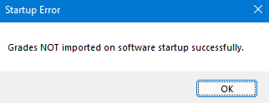

* + 1. If there are no errors, the system shall display that the data uploaded was successful.



* 1. The system shall display the main menu to the user. The system shall display in a new window the user’s computer file explorer.

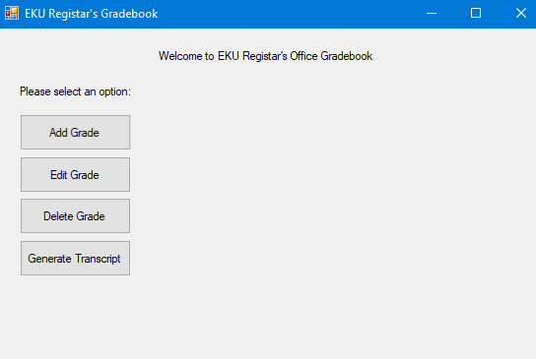

1. The system shall allow a user to add a grade to the database.
   1. The user shall press the “Add Grade” button from the main menu.

* 1. The system shall display a search text box form where the user shall input the student’s ID to search for the student.

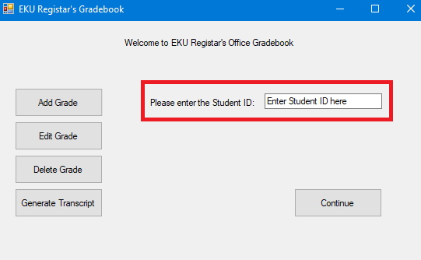

* 1. The user shall press the continue button.

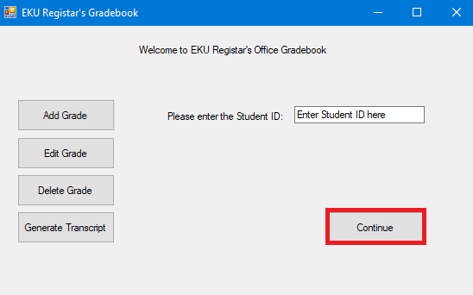

* + 1. If the student is not found, the system shall notify the user and shall allow the user to add the student to the database (R6).

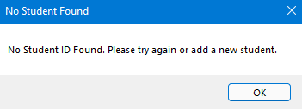

* 1. The system shall display the student’s information including the Student ID, first name, and last name and a data grid view table containing the student’s course and grade history.

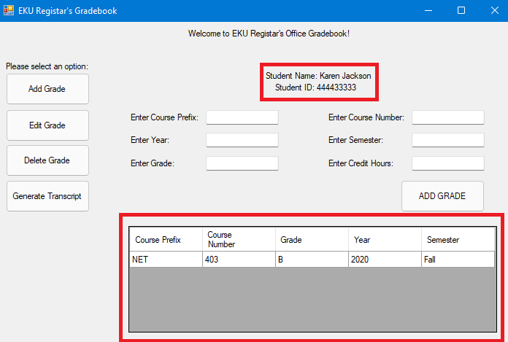

* 1. The system shall ask the user to enter the semester, course prefix, course number, and grade they would like to add for the student.

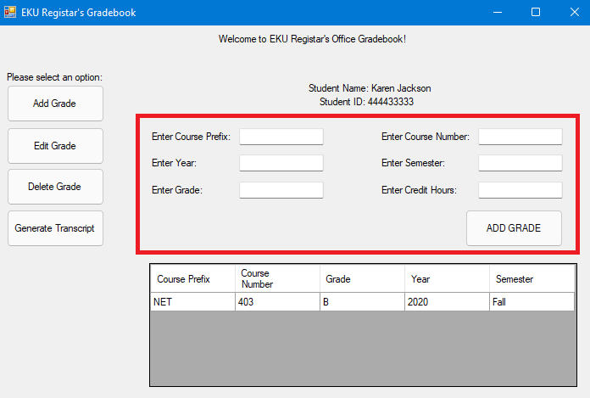

* 1. The user shall press the “Add Grade” button to confirm and add the grade.

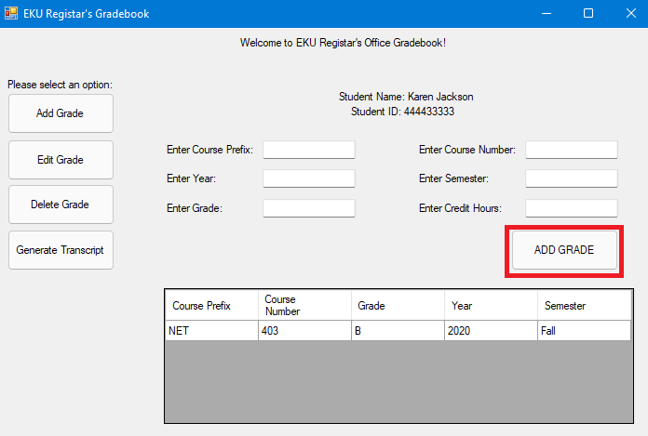

* + 1. If there was an error and the grade was not saved successfully to the database, the system shall notify the user of the error and that the save was not successful.

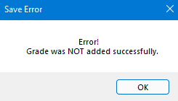

* + 1. If the grade was saved successfully to the database, the system shall notify the user of the success.



* + 1. If the grade was added successfully to the database, the system shall update the data grid view table and show the added row.

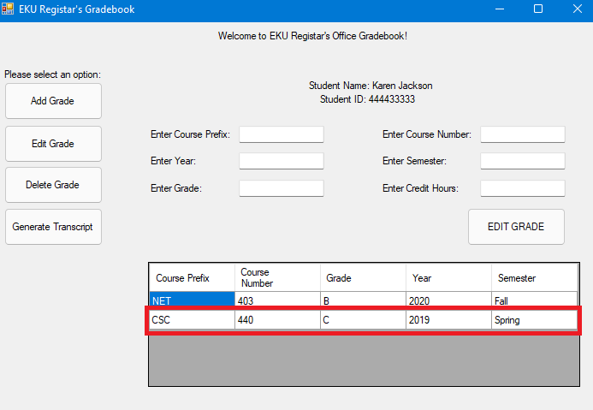

1. The system shall allow the user to edit grades in the database.
   1. The user shall press the “Edit Grade” button from the main menu.

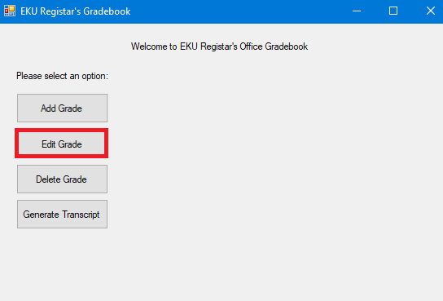

* 1. The system shall display a search text box form where the user shall input the student’s ID to search for the student.



* 1. The user shall press the continue button.



* + 1. If the student is not found, the system shall notify the user and shall allow the user to add the student to the database (R6).



* 1. The system shall display the student’s information including the Student ID, first name, and last name and a data grid view table containing the student’s course and grade history.

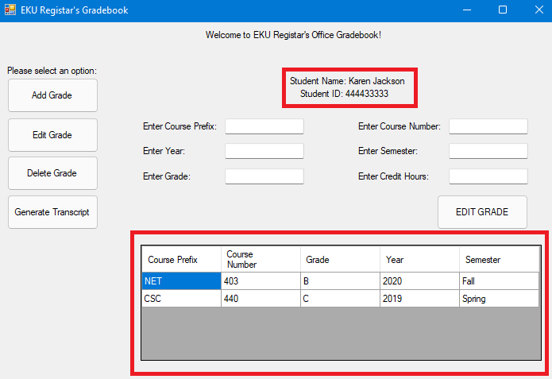

* 1. The system shall ask the user to enter the semester, course prefix, course number for which they would like to edit the grade of as well as selecting the new grade they would like to change it too.

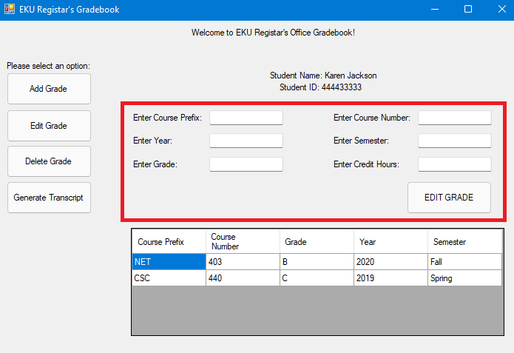

* 1. The user shall press the “EDIT GRADE” button to confirm and edit the old grade with the new grade.

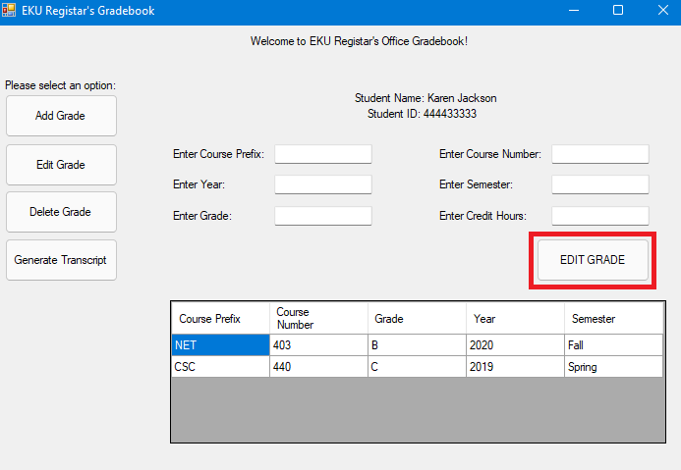

* + 1. If there were errors and the grade was not edited successfully, the system shall notify the user of the error

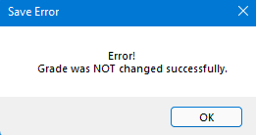

* + 1. If there were no errors, the system shall notify the user that the grade was edited successfully.

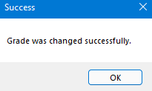

* + 1. If the grade was edited successfully to the database, the system shall update the data grid view table and show the grade successfully edited.

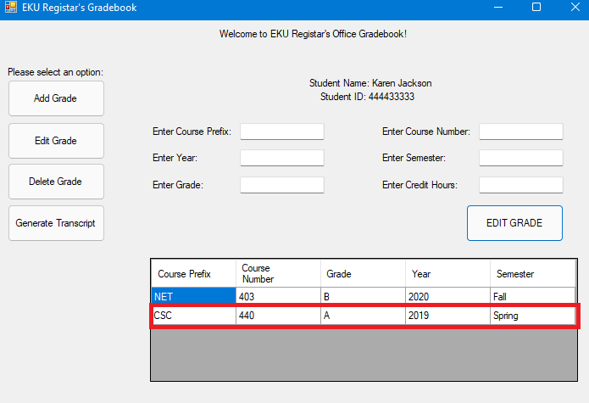

1. The system shall allow the user to delete grades in the database.
   1. The user shall press the “Delete Grade” button from the main menu.

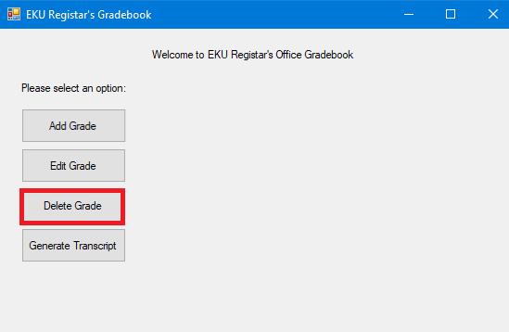

* 1. The system shall display a search form where the user shall input the student’s ID to search for the student.



* 1. The user shall press the continue button.



* + 1. If the student is not found, the system shall notify the user and shall allow the user to add the student to the database (R6).



* 1. The system shall display the student’s information including the Student ID, first name, and last name and a data grid view table containing the student’s course and grade history.

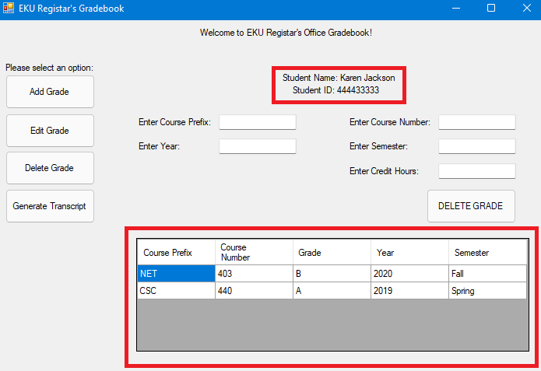

* 1. The system shall ask the user to enter the semester, course prefix, and course number for which they would like to delete the grade of.

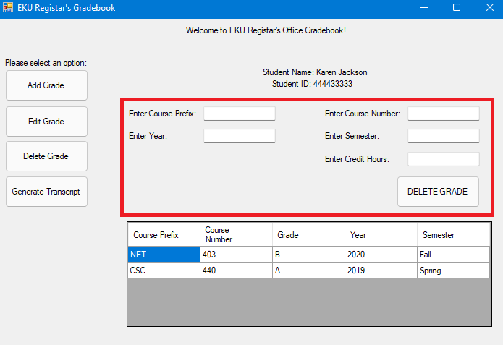

* 1. The user shall press the “Delete Grade” button to confirm.

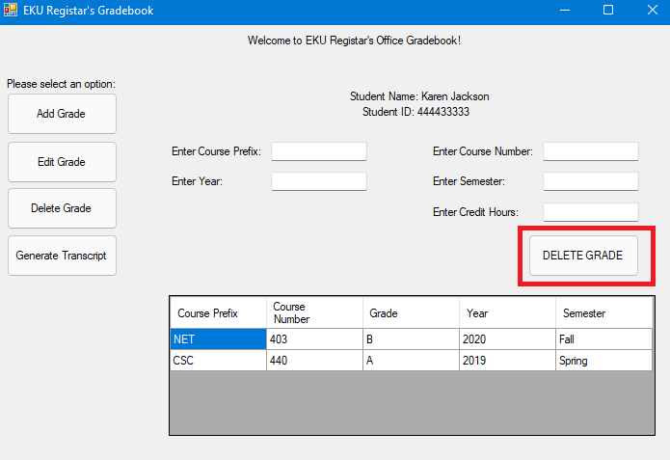

* + 1. If there are errors occurring from the deletion, the system shall display an error message to the user.

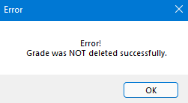

* + 1. If there were no errors, the system shall display a success message to the user that the grade was successfully deleted.

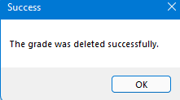

* 1. If the grade was deleted successfully to the database, the system shall update the data grid view table and show the grade column for the selected deleted grade as a ‘_’.

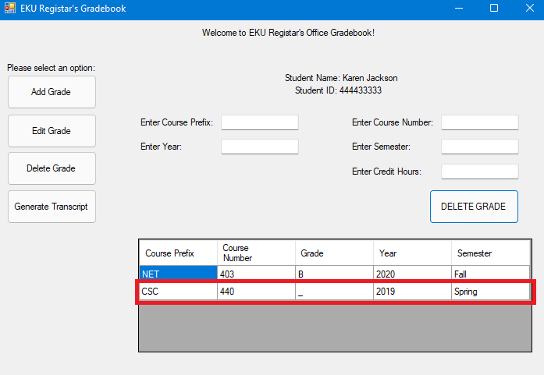

1. The system shall allow the user to generate transcripts for students.
   1. The user shall press the “Generate Transcript” button from the main menu.

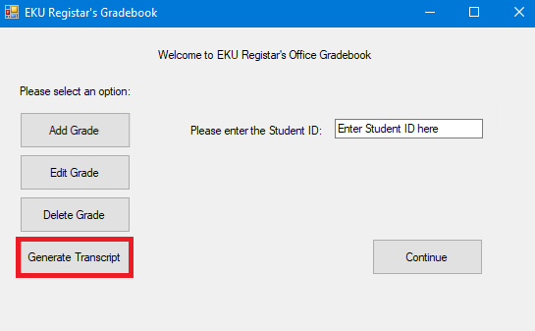

* 1. The system shall display a search form where the user shall input the student’s ID to search for the student.



* 1. The user shall press the continue button.



* + 1. If the student is not found, the system shall notify the user and shall allow the user to add the student to the database (R6).



* 1. The system shall display the user’s computer file explorer to save the pdf with the file name listed as “(student’s first name and last name) Transcript”

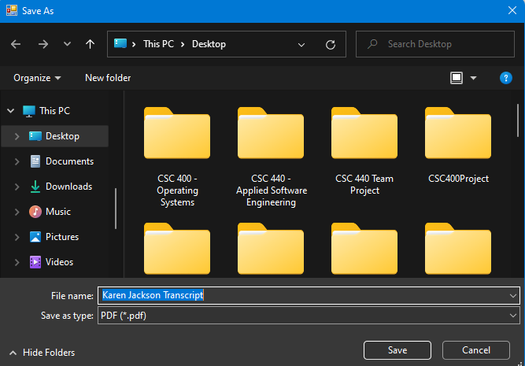

* 1. The user shall press the “Save” button.

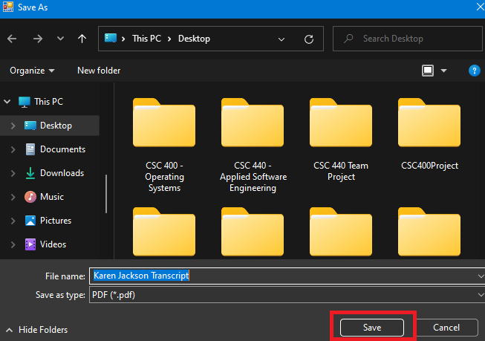

* 1. The system shall display a message to the user that the pdf was saved successfully.



* 1. The system shall then automatically open the pdf for the user and display the Transcript contents.

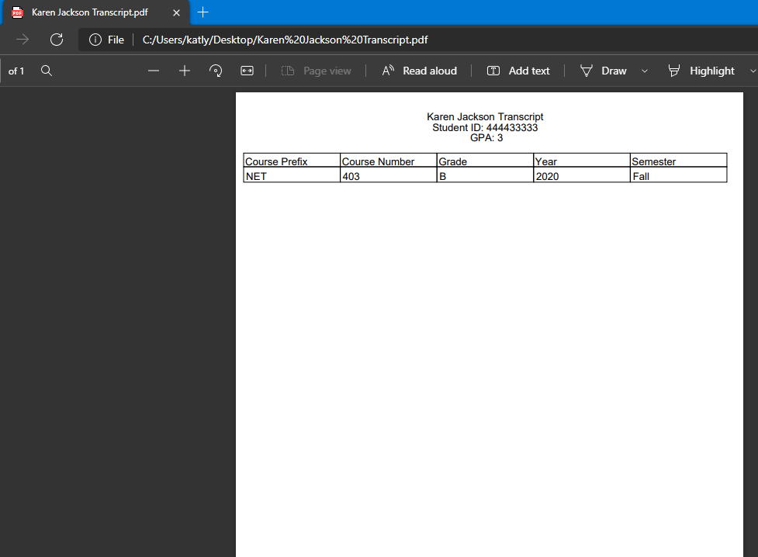

1. The system shall allow the user to add a student to the database.
   1. When the user clicks a button that requires a student ID that is not in the database, the system shall notify the user that the student ID was not in the database and then display the add student button.

* + 1. If the user does not want to add the student to the database, the system shall return to the previous form.
  1. The user shall press the add student button.

* 1. The system shall display the “Add Student” form:
     1. Student ID
        1. This is automatically filled in from the previous form if applicable.
     2. Student First Name
     3. Student Last Name

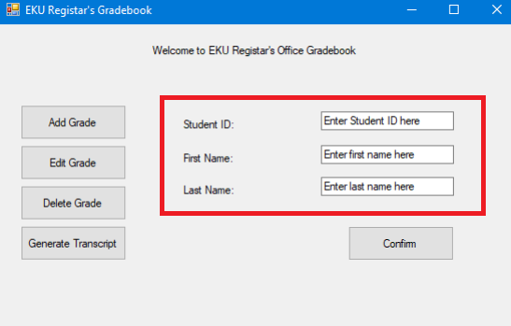

* 1. The user shall press the confirm button to confirm the student’s information entered is correct.

* 1. The system shall add the student to the database and confirm to the user that the student was added successfully.

* 1. The system shall return to the “Add Grade” menu option.

# Use Case Diagram



Figure . Use Case Diagram

This use case is to describe the services provided by the system to the users of the Registrar’s Office:

1. Use case Import Folder Grades – the system shall allow the user to import grades from the Excel files in the specific course folders that were gathered by the Registrar’s Office from the faculty members.
2. Use case Add Grades – the system shall allow the user to add grades to the database.
3. Use case Edit Grades – the system shall allow the user to edit grades from the database.
4. Use case Delete Grades – the system shall allow the user to delete grades from the database.
5. Use case Generate Transcripts – the system shall allow the user to generate transcripts to print for each specific student.

# Class Diagram

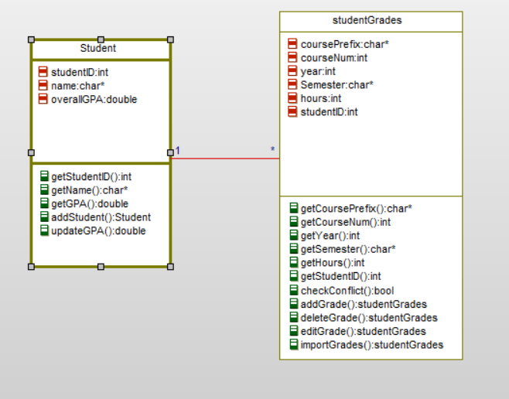

Figure . Class Diagram

# Sequence Diagrams

Use Case: Manually Add Grades

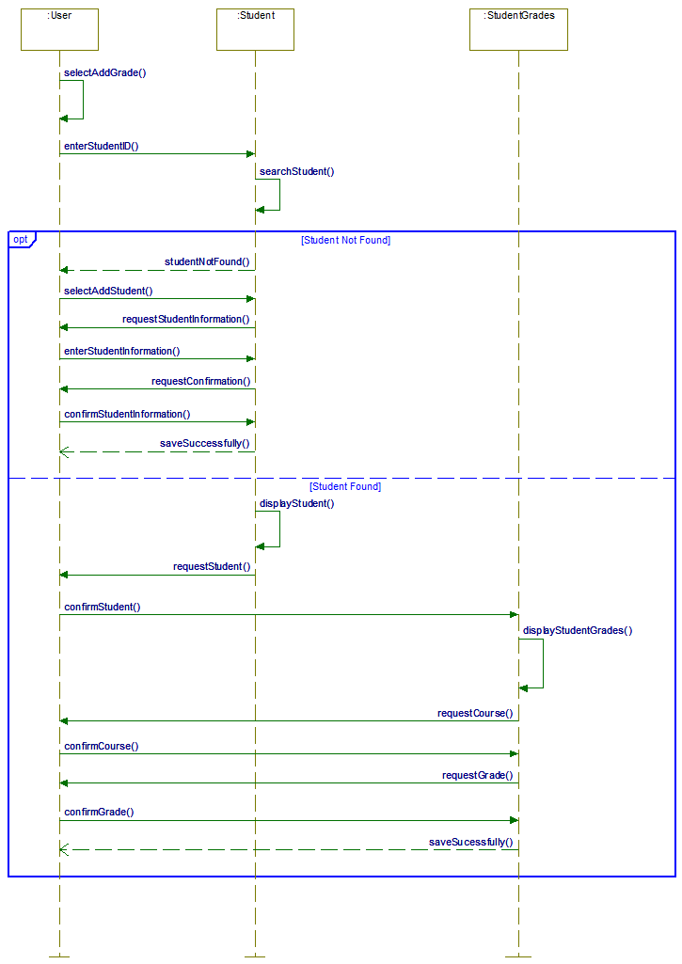

Figure . Sequence Diagram - Manually Add Grades

Use Case: Edit Grades

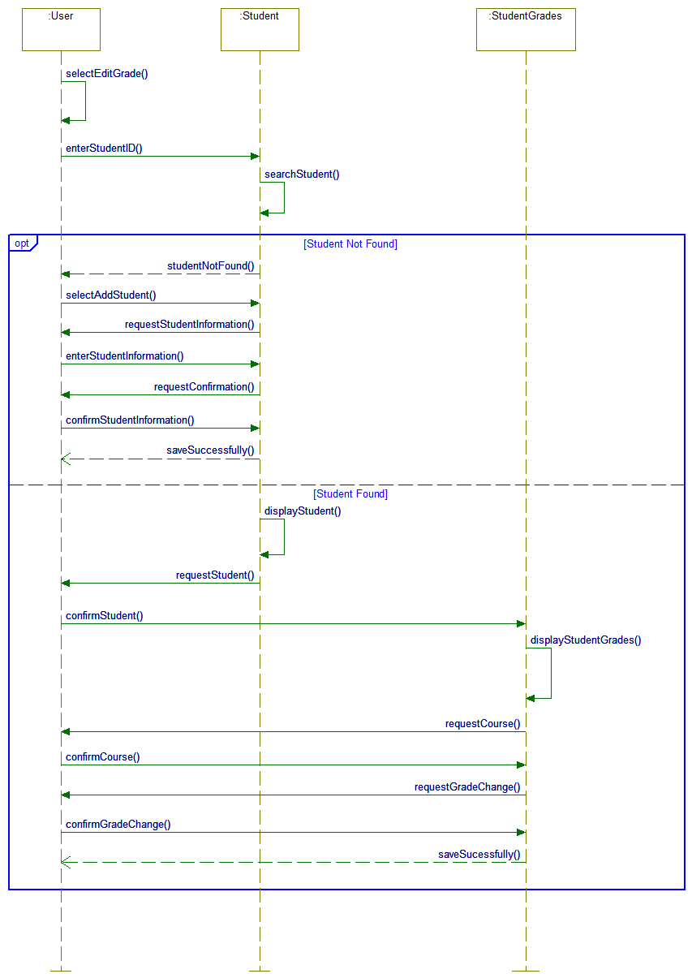

Figure . Sequence Diagram - Edit Grades

Use Case: Delete Grades

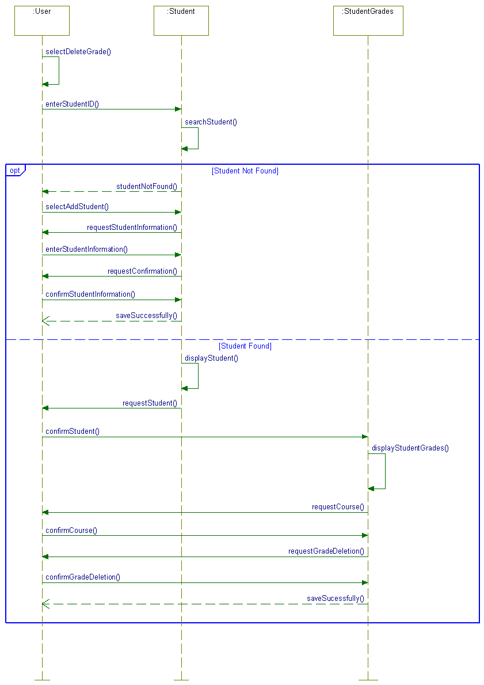

Figure . Sequence Diagram - Delete Grades

Use Case: Generate Transcript



Figure . Sequence Diagram - Generate Transcripts

# State Diagram

Figure 7. State Diagram

Figure 7. State Diagram

# Activity Diagrams

Use Case: Automatically Add Grades

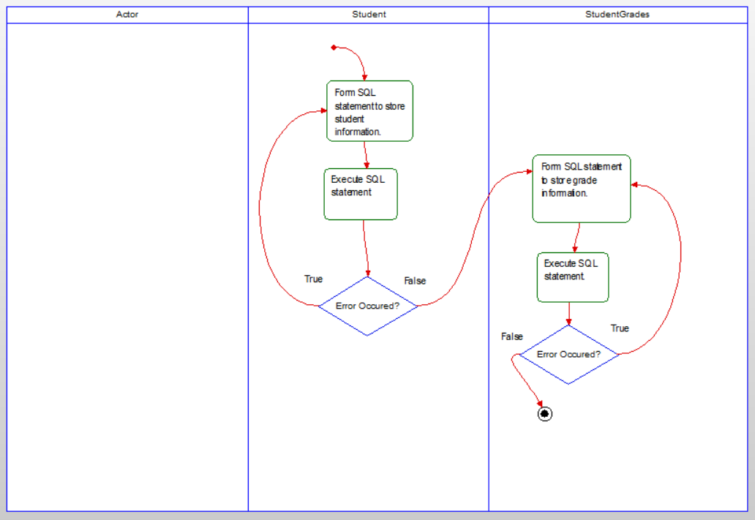

Figure . Activity Diagram - Automatically Add Grades

Use Case: Manually Add Grades

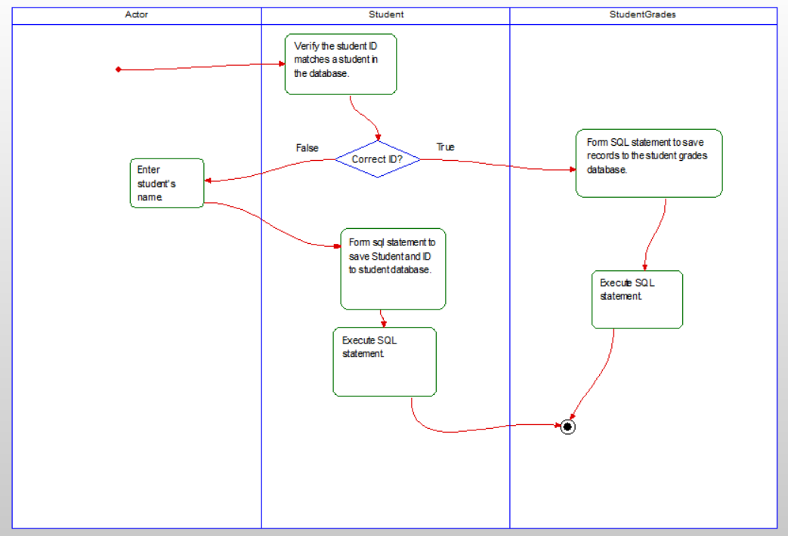

Figure . Activity Diagram - Manually Add Grades

Use Cases: Edit Grades

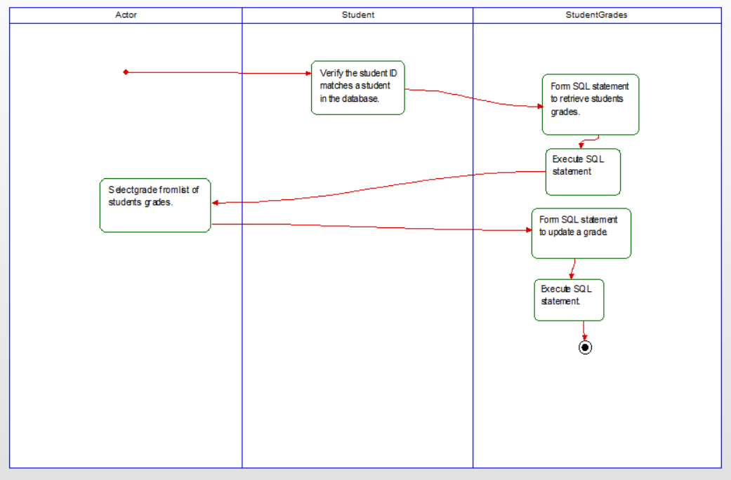

Figure . Activity Diagram - Edit Grades

Use Case: Delete Grades

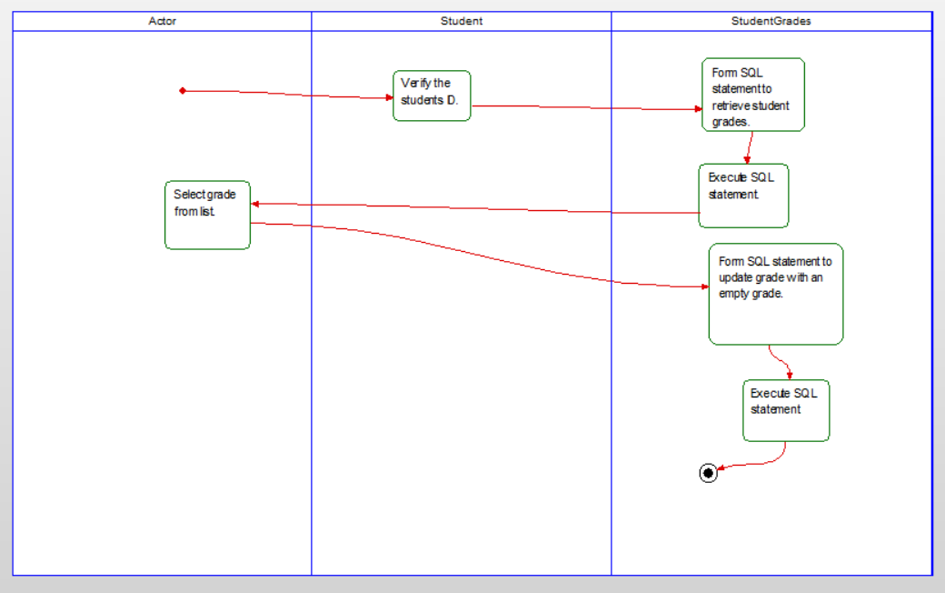

Figure . Activity Diagram - Delete Grades

Use Case: Generate Transcript

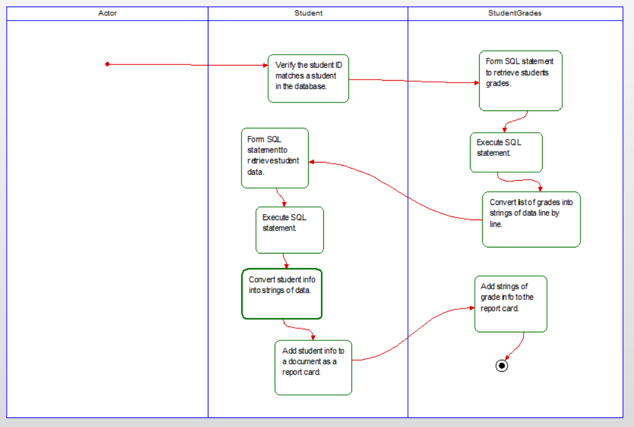

Figure . Activity Diagram - Generate Transcripts

# Database Design

## ER Schema

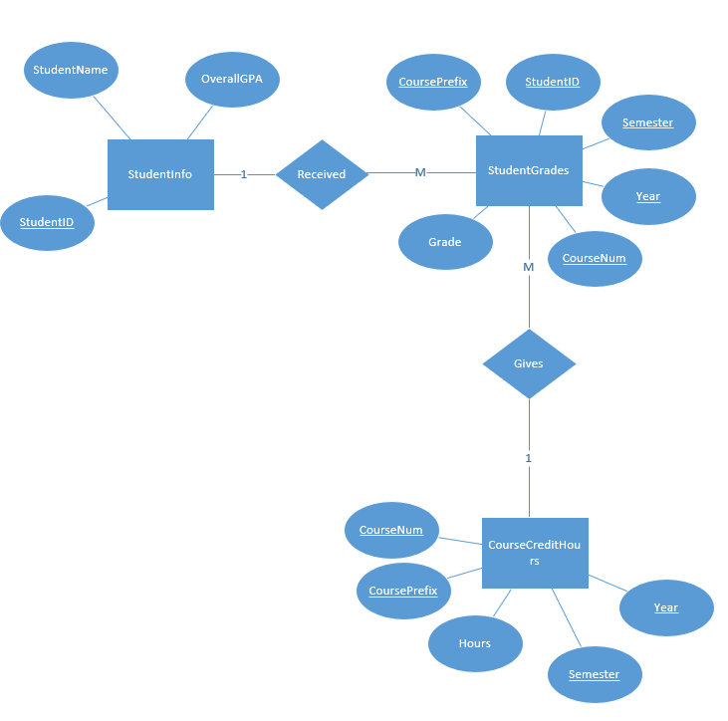

Figure . ER Schema

## Table Schema

Student Information

|  |  |  |
| --- | --- | --- |
| studentID | name | GPA (foreign key) |

Student Grades

|  |  |  |  |  |  |
| --- | --- | --- | --- | --- | --- |
| studentID | coursePrefix | semester | year | grade | courseNumber (foregin key) |

Course Credit Hours

|  |  |  |  |  |  |
| --- | --- | --- | --- | --- | --- |
| courseNumber | coursePrefix | hours | semester | year | grade |

# Conclusion

In conclusion we should be able to do all that is requested from the EKU’s Registrar's Office. The key requests such as the system being able to automatically add grades from the correct folders and users being able to manually add grades, edit grades, delete grades, and generate transcripts for students are the main focus of the software functionality that we will implement. We will be able to complete their requests all within the given frame time and budget while minimizing errors and maximizing proficiency and performance.

# Data Dictionary

1. User – The person who is using the system. This will be a person in the Registrar’s Office.
2. Registrar’s Office Folder – The Registrar’s Office Folder is a network folder that will hold Excel files containing student grades for each specific course, added manually by Registrar staff.
3. System – System refers to the Registrar grade Tracking System.
4. Student ID – Student IDs are kept by the university and match the standard nine-digit format.
5. Database – The database contains three tables: Student Info, Student Grades, and Course Credit hours.
6. Main Menu – The main menu displays the “Add Grade”, “Edit Grade”, “Delete Grade”, and “Generate Transcript” buttons to the user.
7. Transcript – A transcript displays a list of courses taken by the specified student, as well as their grades in these courses. Their ID, name, and GPA will be displayed.
8. Data Grid View – A table that displays year, semester, course prefix, course number, and course grade for each course student has taken where a grade has been assigned too.
9. Student Information – Information about the student containing student ID, first name, and last name.
10. Error Message – Message box from the system explaining that there was an error with the action that was requested from the system.
11. Success Message – Message box from the system explaining that the action that was requested from the system was successful.
12. Term GPA – Grade point average of only the courses the student was enrolled in, in that specific semester.
13. Cumulative GPA – Grade point average of ALL courses from ALL semesters that the student has been enrolled in and completed.
14. Transcript – A transcript displays a list of courses taken by the specified student, as well as their grades in these courses. Their ID, name, and GPA will be displayed.